Assignment-V

Q1: Implement the Simple Linear Regression for the data given below and predict the house price for a house with plot size 3000, 2000 and 1500 feet:

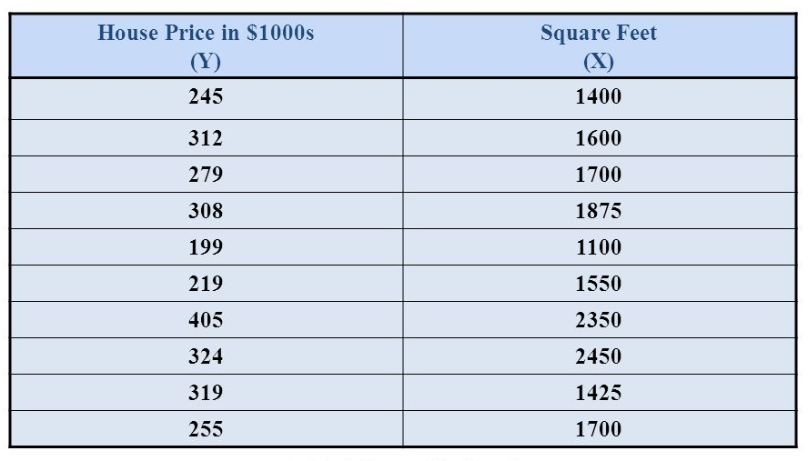

Q2: Implement the Multiple Linear Regression for the data given below and predict the stock index price if interest rate is 1.5 and unemployment rate is 5.8.

